Viewing Existing Schemes 2
1.1. Search by Pension Code 2
1.2. View Tiered Contribution Rates 3
1. Adding a New Pension Scheme 4
1.1. Copy an Existing Scheme 4
1.2. Enter Pension Scheme Details (Page 1) 5
1.3. Enter Pension Scheme Details (Page 2) 7
1.4. Enter Tiered Rates 9
1.5. Enter Pension Scheme Details (Page 3) 10
2. Editing Existing Pension Schemes 11
2.1. Amend Contribution Rates (EEs and/or ERs) 11
2.2. Amend Pay Codes on Scheme 12
2.3. Amend Other Details 13
3. Maintaining the Voluntary Salary Cap (VSC) rates 13
3.2. Amend DIS/Ill Health Above VSC % 14
3.3. Amend ER VSC Deficit % 15
4. Editing the Auto-Enrolment Notifications 16
4.2. Edit Message Text 17
4.3. Edit Message Attachment 19
4.4. Edit Conditions 20
5. Editing the Auto-Enrolment Parameters 21
5.2. Edit Pension Rules 21
5.3. Edit Earnings Parameters 23
5.4. Edit State Pension Ages 24

Knowledge Article: Pension Schemes

Reports

The following reports should be updated whenever there is any change to pension rates:
- PERSUP14 - Pay scale interface to X5
- PERSUP15 - Pay scale interface to finance website
- PAYPEN02 – Pensions Monthly Contributions

Other reports may need updating depending on the scheme you have created/amended. Speak to Payroll and Pensions for guidance.
Other related documents

Configuration of Auto-Enrolment events in HRISPRD
Pension Scheme TEMPLATE
Pension Schemes Knowledge Article

Viewing Existing Schemes

Payroll Dashboard > Settings > Codes > Pension Scheme

The Pension Schemes window will open:

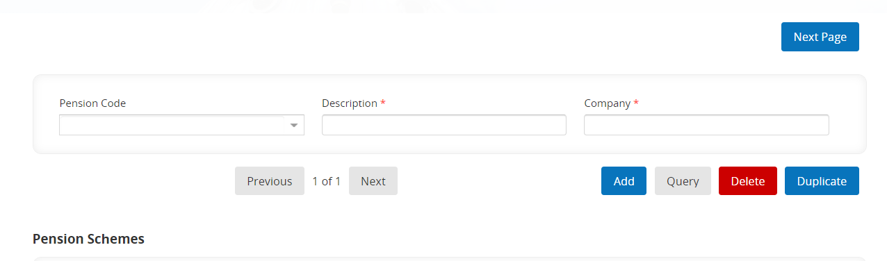

Search by Pension Code
    - Start typing the scheme number or select from the drop down list and wait for the Description to populate:
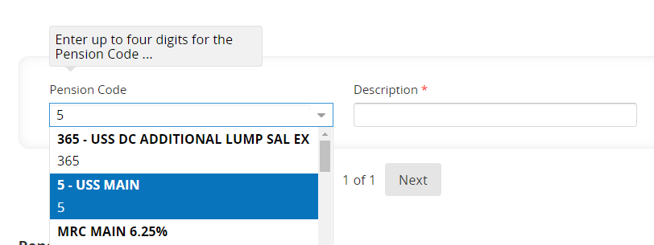
    - The first page of the current setup for that pension scheme will be displayed:
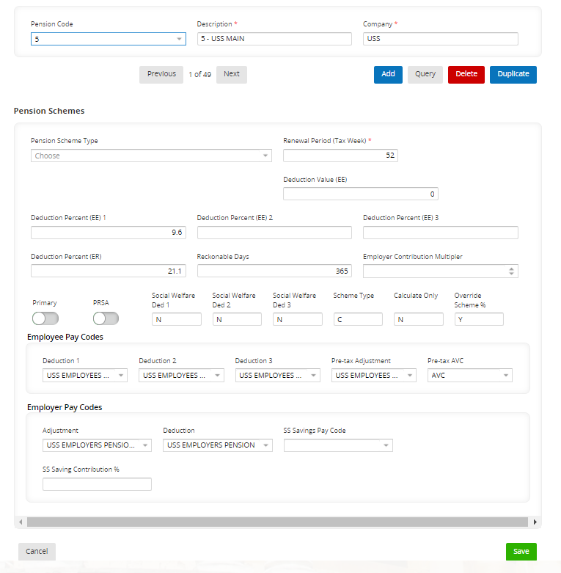
    - Click on Next page to view further details for your selected pension scheme:
 | NB: Ignore this display 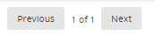 as this does not indicate which page of the current scheme setup you are viewing
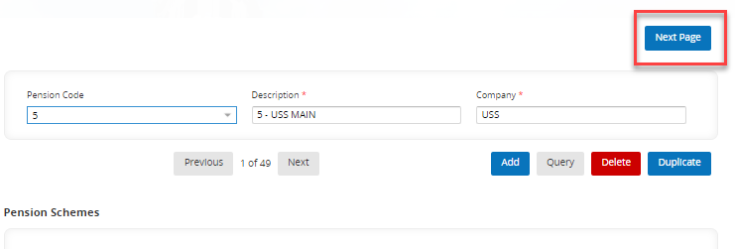

 | NB: Tiered (or 'banded') pension schemes are schemes in which each member’s rate of contributions is dictated by what tier (or 'band') their salary falls into. Members who earn less contribute a lower rate, while members who earn more contribute a higher rate.

View Tiered Contribution Rates
    - Select the appropriate Pension Scheme Code then click on Next page to view further scheme details. NB: The Banded Scheme Type field should say 'Tiered':
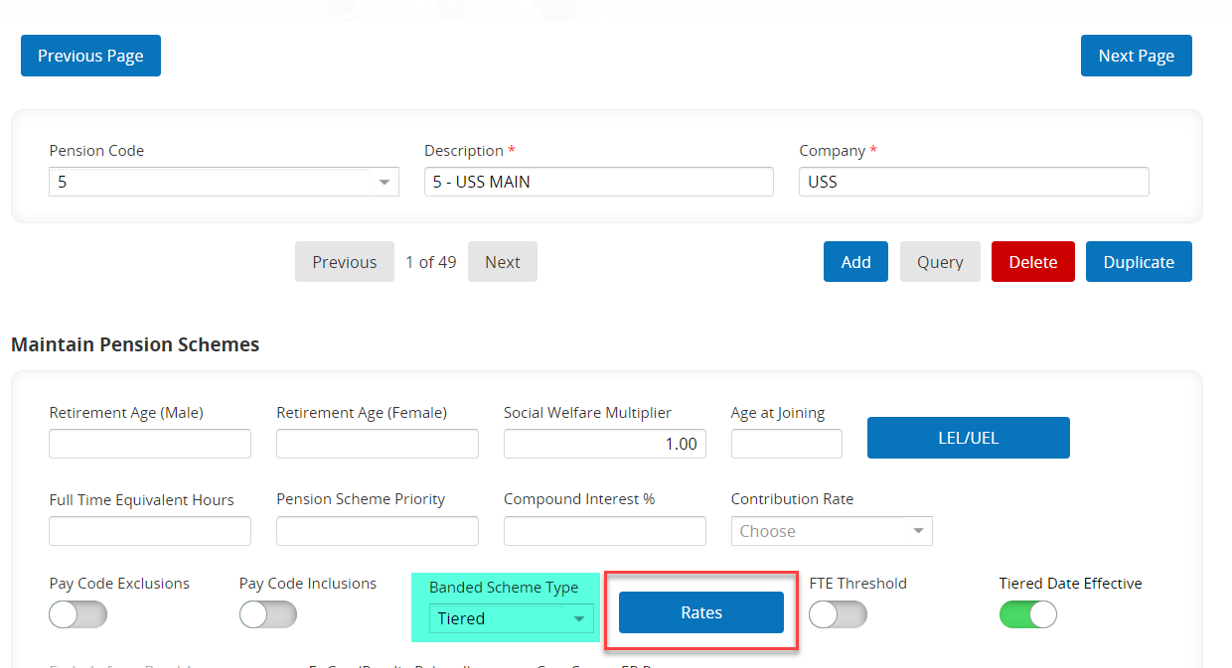

    - Click the Rates button to display the contribution rates (the EE % and ER % fields). You can see the change history for the tier by looking at the Date Effective column. The most recent rates are always displayed at the top:
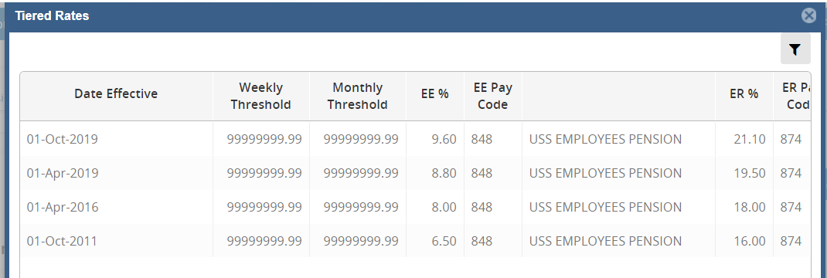
    - To exit the screen click on the x in the top right corner (NB: the cancel button doesn't work isn't this screen)

Adding a New Pension Scheme
 | NB: Payroll must complete a Pension Scheme Template whenever a new pension scheme is required. Refer to this document in order to complete the steps below.

Payroll Dashboard > Settings > Codes > Pension Scheme

The Pension Schemes window will open:



Copy an Existing Scheme
    - Open the Pension Scheme Template that Payroll have provided and refer to the 'Copy Scheme' row:
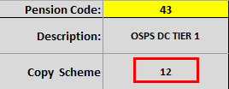
    - On the Pension Schemes screen, enter/select the Pension Scheme you wish to copy. Once it is displayed click on Duplicate.

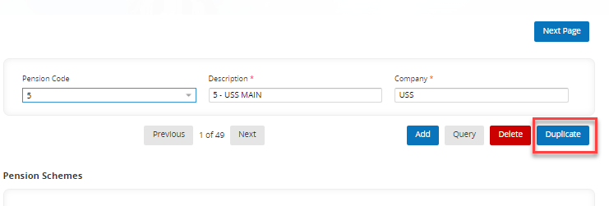
    - The pension scheme you selected will now be copied into a new record. Edit the Pension Code, Description (and Company if applicable) as specified on the spreadsheet.

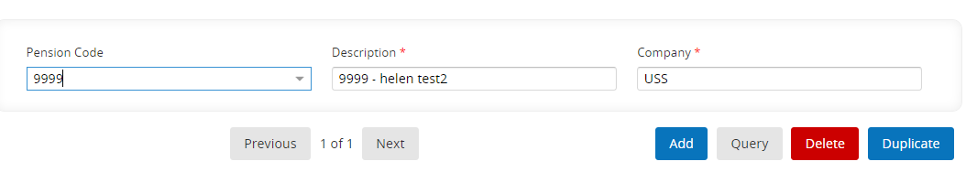
    - Click 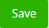.

Enter Pension Scheme Details (Page 1)
    - Now refer to the 'Page 1' section of the Pension Scheme Template, and use the information there to complete the fields on the screen:
Field Name (*mandatory) | Description
Maintain Pension Schemes
Pension Code* | Enter the value provided by Payroll.
Description* | Enter the value provided by Payroll.
Company* | The name of the scheme provider, e.g. USS, OSPS, NHS. This will usually carry over from the scheme you have copied; if not, enter the value provided by Payroll.
Pension Scheme Type | N/A
Renewal Period (Tax Week)* | This will usually carry over from the scheme you have copied; if not, enter the value provided by Payroll.  The value of this field determines the payroll week when the Pension Scheme Tax Year Cumulatives are reset. If the cumulatives should be renewed on payroll week 1, enter '1', if on week 40, enter '40', and so on.
Deduction Value (EE) | Enter a value if one has been provided, otherwise leave blank.  This field refers to the value of the fixed employee (EE) contribution to the pension.
Deduction Percent (EE) 1 | Enter a value if one has been provided, otherwise leave blank.  This field refers to the employee’s percentage contribution based on their pensionable pay (pay with the 'EE pensionable' flag selected).
Deduction Percent (EE) 2 | Enter a value if one has been provided, otherwise leave blank.
Deduction Percent (EE) 3 | Enter a value if one has been provided, otherwise leave blank.
Deduction Percent (ER) | Enter a value if one has been provided, otherwise leave blank.  This field refers to the employer’s (ER) percentage contribution (based on pay codes with the 'Pensionable ER Indicator' flag selected).
Reckonable Days* | This will usually carry over from the scheme you have copied; if not, enter the value provided by Payroll.
Primary | N/A
PRSA | N/A – only relevant for Irish pension schemes
Social Welfare Ded. 1* | Enter the value provided by Payroll ('Y' or 'N').
Social Welfare Ded. 2* | Enter the value provided by Payroll ('Y' or 'N').
Social Welfare Ded. 3* | Enter the value provided by Payroll ('Y' or 'N').
Scheme Type* | Enter the value provided by Payroll:  - 'C' for contributory pension schemes  - 'N' for non-contributory pension schemes
Calculate Only* | Enter the value provided by Payroll ('Y' or 'N').
Override Scheme %* | Enter the value provided by Payroll ('Y' or 'N').  For employee contributory pensions, select the checkbox if you wish for the EE % contributions to be taken from the employee’s profile rather than the standard EE % contribution set on the pension.
Employee Pay Codes
Deduction 1* | Enter the value provided by Payroll.  This field refers to the pay code against which 'Deduction Percent (EE) 1' will be posted (if the scheme is based on a percentage calculation). If the scheme is based on a fixed value, the 'Deduction Value (EE)' will also be posted against this pay code.
Deduction 2* | Enter the value provided by Payroll.  This field refers to the pay code against which 'Deduction Percent (EE) 2' will be posted. This field is not relevant for schemes with fixed deductions.
Deduction 3* | Enter the value provided by Payroll.  This field refers to the pay code against which 'Deduction Percent (EE) 3' will be posted. This field is not relevant for schemes with fixed deductions.
Pre-tax Adjustment* | Enter the value provided by Payroll.  This field refers to the pay code against which the pre-tax adjustments will be posted. It may be the same as the code for 'Deduction 1'.
Pre-tax AVC* | Enter the value provided by Payroll.  This field refers to the pay code against which the pre-tax AVC contributions will be posted.
Employer Pay Codes
Adjustment* | Enter the value provided by Payroll.  If there is a requirement to make one-off adjustments to the ER contribution, this can be recorded against the employee’s pension scheme record. (Refer to the 'Deduction Adjustment ER' field on the Employee Pension Details screen). These adjustments will then be posted to the pay code specified here.
Deduction* | Enter the value provided by Payroll.  This field refers to the pay code against which the ER contributions for this scheme will be posted.

    - Click .
Completed 'Page 1' screen:
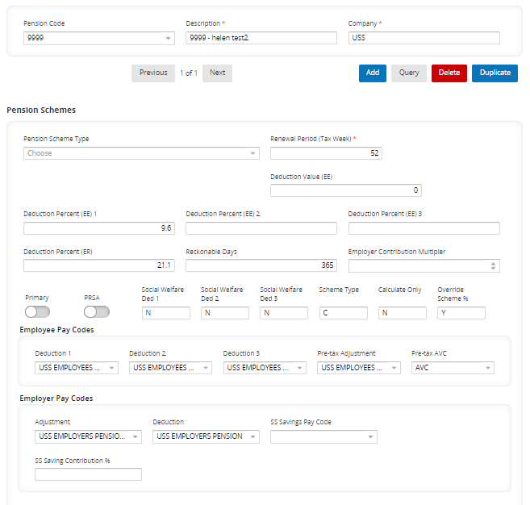

Enter Pension Scheme Details (Page 2)
    - Click on Next page to access further details for the pension scheme:

 | NB: Ignore this display  as this does not indicate which page of the current scheme setup you are viewing
    - Now refer to the 'Page 2' section of the Pension Scheme Template and complete the fields on the screen as specified:
Field Name (*mandatory) | Description
Maintain Pension Schemes
Retirement Age (Male) | N/A
Retirement Age (Female) | N/A
Social Welfare Multiplier*  [LEL/UEL] | This will usually carry over from the scheme you have copied; if not, enter the value provided by Payroll.  [Speak to Payroll about whether LEL/UEL values need to be set for the scheme.]
Age at Joining | N/A
Full Time Equivalent Hours | N/A
Pension Scheme Priority | N/A
Compound Interest % | N/A
Contribution Rate | N/A
Pay Code Exclusions | N/A
Pay Code Inclusions | N/A
Banded Scheme Type  [Rates] | Enter a value if one has been provided, otherwise leave blank.  [If the value is 'Tiered', you will need to enter the tiered Rates for the scheme. See step 2.4. for details.]
FTE Threshold | N/A
Tiered Date Effective | Toggle on or leave blank (indicated by 'Y' or 'N' on the Pension Scheme Template).  [If this is toggled ON the date effective column will appear in the Tiered Rates entry screen]
Exclude from Band Assessment | N/A
ER Cost (Payslip Related) | N/A
Cost Centre ER Percent | N/A
SCON | This is the 'Scheme Contracted Out Number' and only applies to older pension schemes. Leave blank for any newly-created schemes.
ER Top Up Required
Pre Niable Scheme | Enter the value provided by Payroll.
NHS Pension | This indicator was created for the NHS Pension scheme changes due to be implemented from 1 Oct 2022
Pensionable Earning Cap | TBC
Pension Pro Rata
Pension Pro Rata Calculation | N/A
Pension Renewal
N/A
GL Control A/C
Cost Centre* | Enter the value provided by Payroll.  This field refers to the Cost Centre that the ERs contributions are costed to.
Location | Enter a value if one has been provided, otherwise leave blank.
Expense* | Enter the value provided by Payroll.  This field refers to the Expense Code that the ERs contributions are costed to.
Project | Enter a value if one has been provided, otherwise leave blank.  This field refers to the Project that the ERs contributions are costed to.
Notes
N/A

    - The 'Pension Renewal' and 'Notes' sections can be ignored.

    - Click 

Completed 'Page 2' screen:
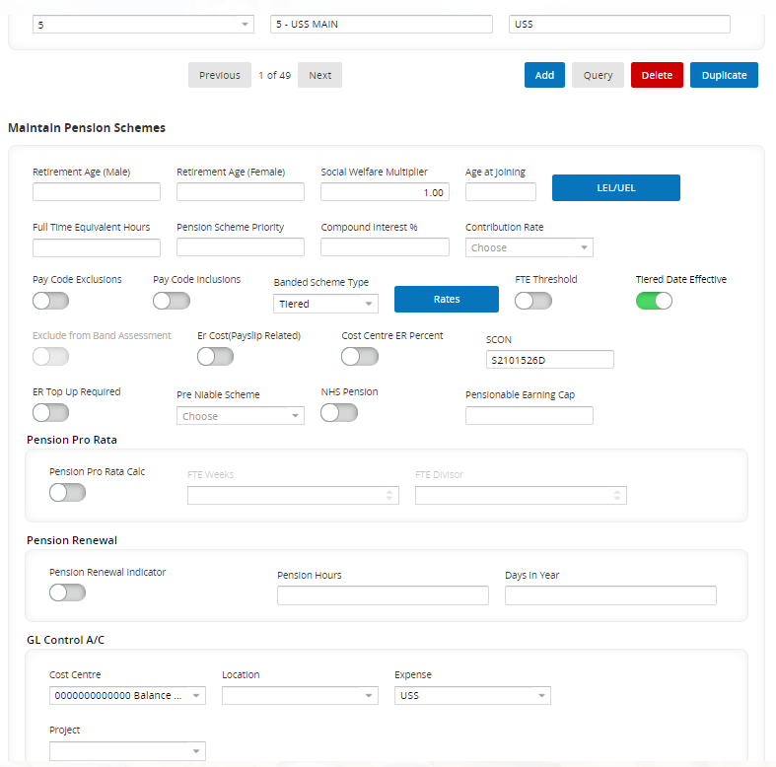

Enter Tiered Rates
    - If your Banded Scheme Type is 'Tiered', you will need to add the tiered rates for the scheme. Click the Rates button:
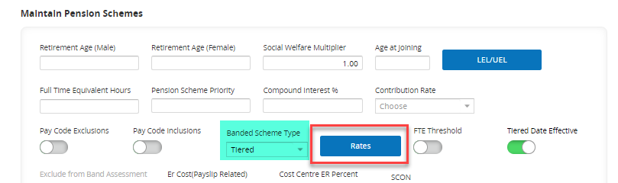
    - The Tiered Rates window will open.

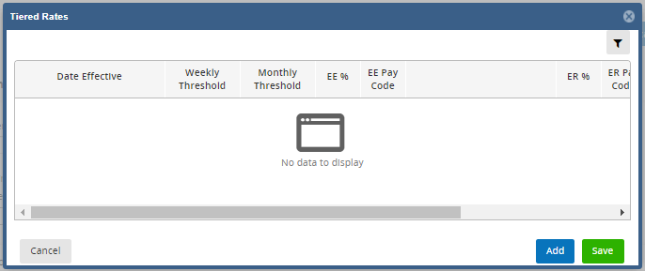

 | NB: The Date Effective column will only be displayed if the Tiered Date Effective indicator is ON
    - Click at the bottom of the screen to insert a row.

    - Enter the details as follows:

Field Name (*mandatory) | Description
Maintain Pension Schemes
Date Effective | Enter the value provided by Payroll if applicable.
Weekly Threshold | Enter the value provided by Payroll.
Monthly Threshold | Enter the value provided by Payroll.
EE % | Enter the value provided by Payroll.
EE Pay Code  [Description] | Enter the value provided by Payroll.  [The description of the pay code will default into the field.]
ER % | Enter the value provided by Payroll.
ER Pay Code  [Description] | Enter the value provided by Payroll.  [The description of the pay code will default into the field.]

Example of a completed rates screen

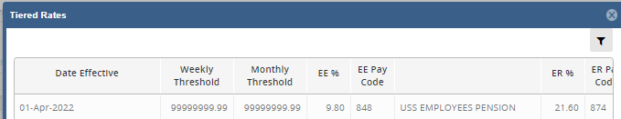

    - Click  then click on the cross in the top right hand corner of the window to exit. (NB: the cancel button doesn't work in this screen)

Enter Pension Scheme Details (Page 3)
    - Click on Next page to access further details for the pension scheme:

 | NB: Ignore this display  as this does not indicate which page of the current scheme setup you are viewing
    - Now refer to the following sections of the Pension Scheme Template and use the information there to complete the fields on the screen:
Field Name (*mandatory) | Description
Maintain Pension Message
N/A
Provider Details
Provider Identifier | Enter the value provided by Payroll (usually blank).
Provider E-mail Address | Enter the value provided by Payroll (usually blank).
Provider Address 1 | Enter the value provided by Payroll (usually blank).
Provider Address 2 | Enter the value provided by Payroll (usually blank).
Provider Address 3 | Enter the value provided by Payroll (usually blank).
Provider Address 4 | Enter the value provided by Payroll (usually blank).
Employer Details
Employer Identifier | Enter the value provided by Payroll (usually blank).
Scheme Reference Details
Scheme Reference | Enter the value provided by Payroll.

    - Click Save.

Editing Existing Pension Schemes

Navigate to: Payroll Dashboard > Settings > Code > Pension Schemes

The Pension Schemes window will open:



Amend Contribution Rates (EEs and/or ERs)
    - On the Pension Schemes screen, enter/select the Pension Code you wish to edit.
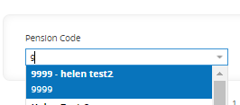
    - Update the 'Deduction Percent (EE and/or ER) 1' field with the new value(s):
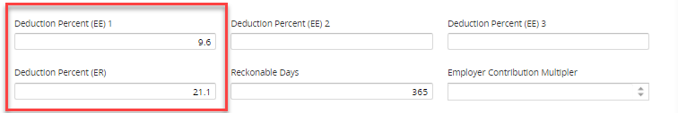
    - Click on Next page to access further details for the pension scheme.

 | NB: Ignore this display  as this does not indicate which page of the current scheme setup you are viewing
    - Check the 'Banded Scheme Type' field; if it’s set to 'Tiered', you will need to update the tiered rates:
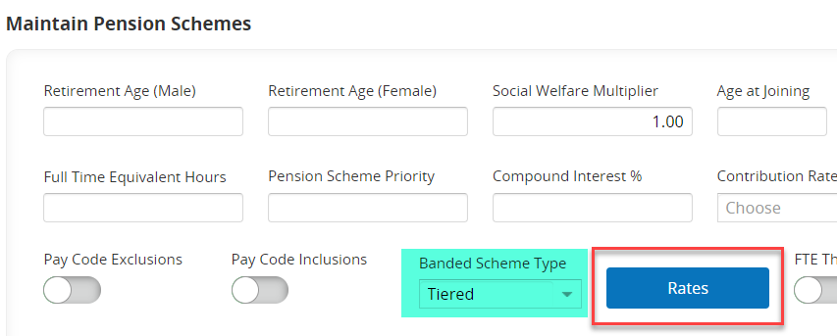
    - Click the Rates button. The 'Tiered Rates' window will open.

    - Click to insert a new row. Enter the new 'EE / ER %' rate(s) into the relevant field(s). Copy all other details from the previous row.
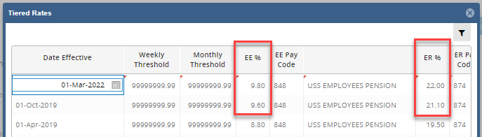

    - Click  then click on the cross in the top right hand corner of the window to exit. NB: The cancel button doesn't work in this screen.

Amend Pay Codes on Scheme
 | NB: Never change the pay codes on a pension scheme unless you have been explicitly instructed to do so by Payroll.

    - On the Maintain Pension Schemes screen, enter/select the Pension Code you wish to edit.


    - The pension scheme will be displayed onscreen. Update the appropriate fields in the Employee and/or Employer Pay Codes sections with the new values:
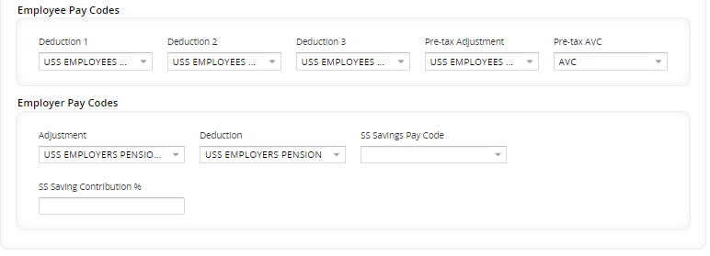
    - Click  then click on the cross in the top right hand corner of the window to exit.

Amend Other Details
    - On the Pension Schemes screen, enter/select the Pension Code you wish to edit.


    - Click into the field you wish to edit and enter the new values.
    - Click .

Maintaining the Voluntary Salary Cap (VSC) rates
 | NB: Pensions must inform the HRIS Support Desk whenever the VSC contribution rates change, however it is best to always check especially where the following USS Pension Scheme Codes have an ER % change: 5, 6, 7 & 8. The HRIS Analyst must process the request as a Change within OSM.

CorePay > Employee > Core Data Talk > Generate USS Returns

 | NB: This process will remain in the Back Office for the foreseeable future.

The USS Pension Returns window will open. There are two values you can enter in the Institution Number field:

- 2700 – this will bring up the configuration for the University of Oxford
- 2734 – this will bring up the configuration for Linacre College

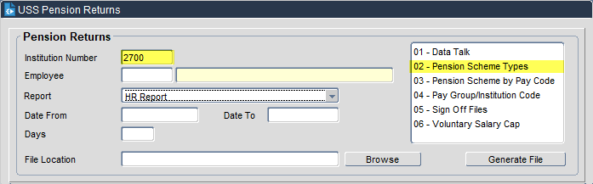

    - Double-click the option for 'Pension Scheme Types' in the select menu on the right. The Pension Scheme Identification window will open. This is where the configuration is done:

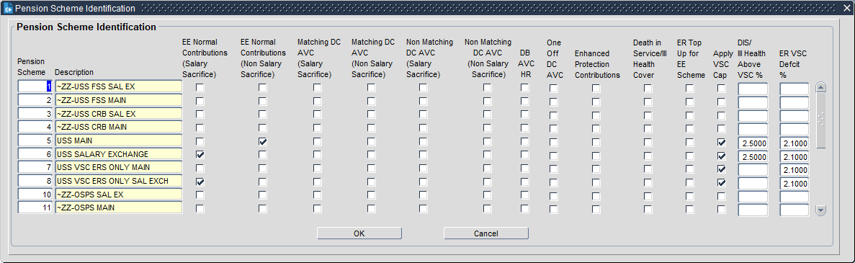

Amend DIS/Ill Health Above VSC %

    - On the Pension Scheme Identification screen, click into the 'DIS/Ill Health Above VSC %' column. Click the Query icon.
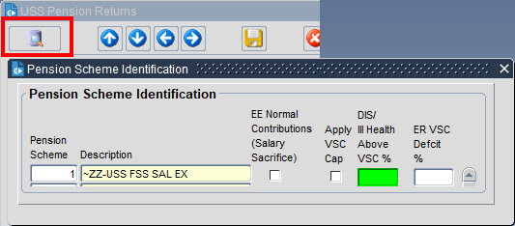

    - Enter the wildcard symbol '%' into the field and click on the green tick to execute a query.
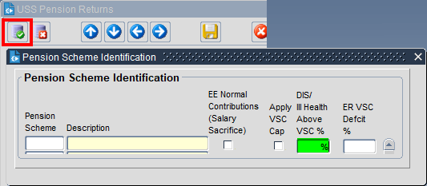
All pension schemes which have a value for the 'DIS/Ill Health Above VSC %' column will be returned.
    - Update the column with the appropriate values.

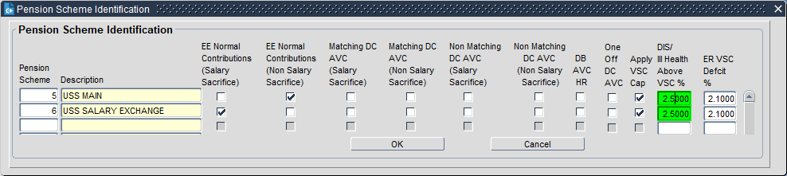

    - Click the yellow disk icon () to save your changes.

Amend ER VSC Deficit %

    - On the Pension Scheme Identification screen, click into the 'ER VSC Deficit %' column, then click the Query icon.
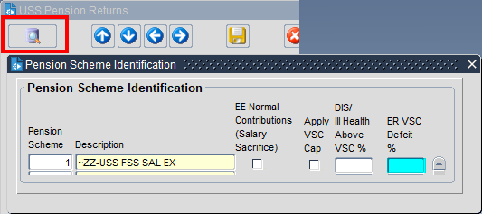
    - Enter the wildcard symbol '%' into the field and click on the green tick to execute a query.

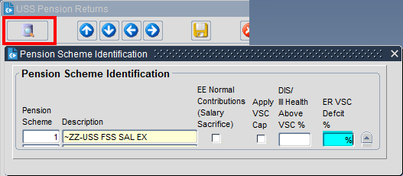

All pension schemes which have a value for the 'ER VSC Deficit %' column will be returned.
    - Update the column with the appropriate values.
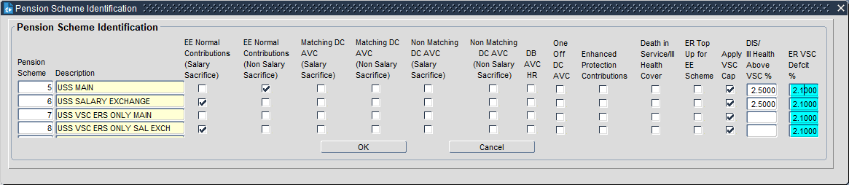
    - Click the yellow disk icon () to save your changes.

Editing the Auto-Enrolment Notifications
 | NB: If you change the employee (EE) contribution rates for a pension scheme, you may need to edit the Auto-Enrolment letters for that pension scheme to reflect the new EE rates. You may also need to update the Auto-Enrolment notifications after creating a new pension scheme. Always ask Pensions to confirm whether the Auto-Enrolment notifications will need to be updated following a change to a pension scheme or the creation of a new pension scheme. The latest version of the Auto Enrolment PDF, which includes rates, can be found at P:\PROJECTS\HRIS Programme\12. Support\Auto Enrolment\Letters for email notifications. Liaise with the Pension Administration Specialist (Linda Howse) for any updates or a new version or be provided.

People Management>Command Centre>HR Admin Setup Settings>Event Management> HR event configuration

The CoreHR Events window will open.

    - Select Event Category 'Auto Enrolment Pension':

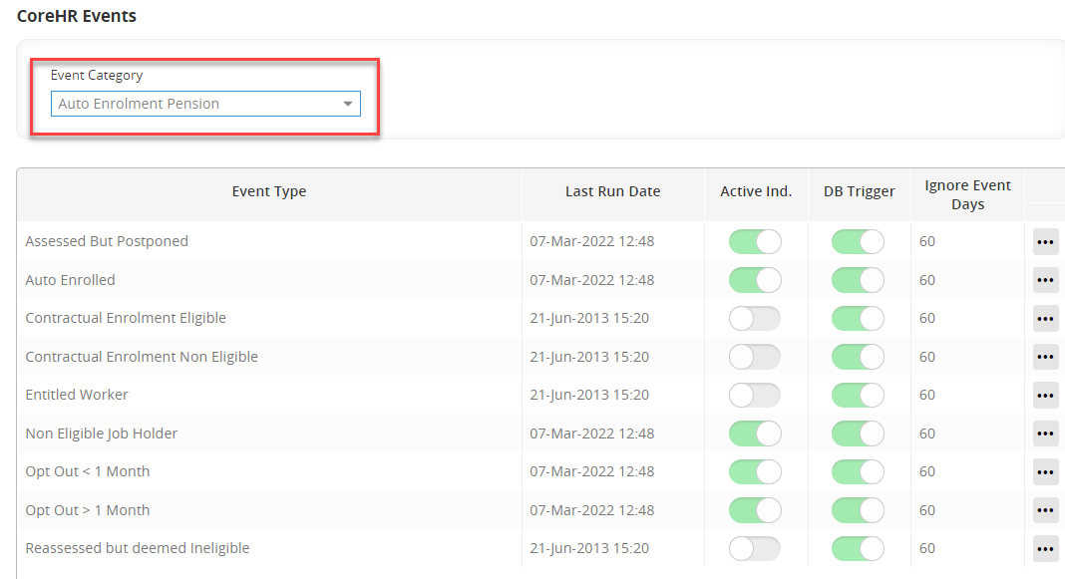

Edit Message Text
    - In the Event Maintenance window, click on the ellipses against the 'Event Type' you want to change and click Edit. In the pop-up window, select the notification you want to edit and click Edit:
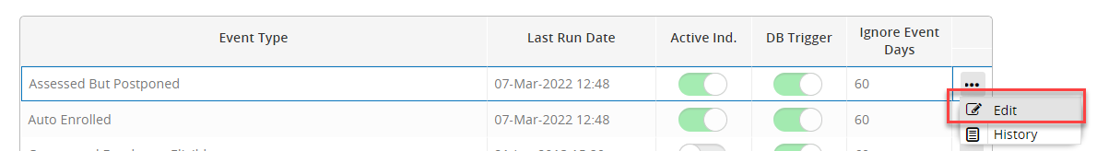
    - The Event type window will open. The individual events will be displayed in the Event Notifications section. Click on the ellipses against the event you wish to amend and choose Edit.
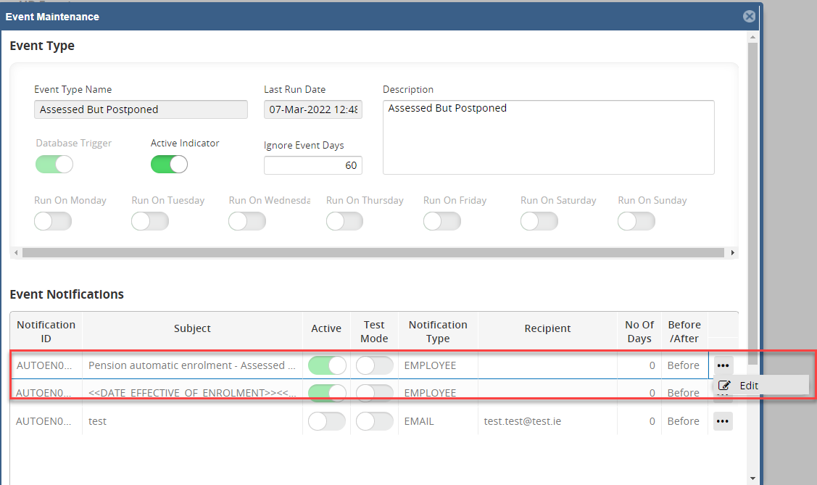

    - The Event Notification window will open:

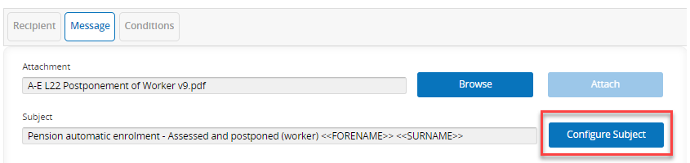

    - The screen is broken down into three tabs. Open the 'Message' tab.
 | NB: Any item surrounded by <<darts>> is a merge field item. You can add items by selecting them from the 'Available Items' section at the bottom of the screen.
    - To edit the subject, click the Configure Subject button. A window will open in which you can edit the subject line.

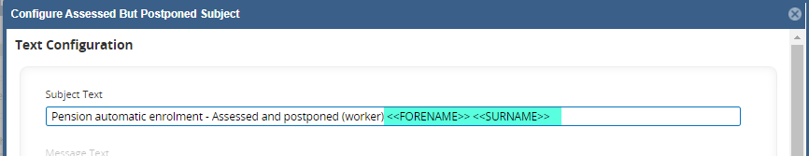

    - When you are done, click Save, then click on cancel or the cross to exit.
    - To change the message text, click on Configure Message. A window will open in which you can edit the message text:
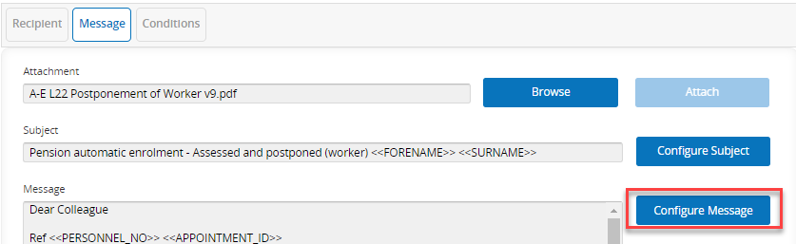
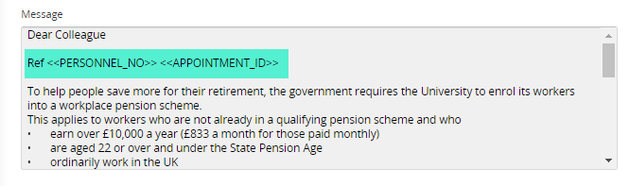

 | NB: Any item surrounded by <<darts>> is a merge field item. You can add items by selecting them from the 'Available Items' section at the bottom of the screen.

    - Make the changes as required, click Save and then OK the confirmation message.
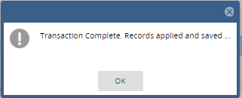

    - Click on Cancel or the cross at the top of the screen to exit.
    - Click the View Test Email button to check that your changes are now appearing in the email template:
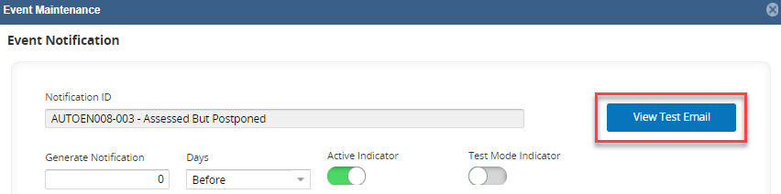

    - You will need to enter/select an employee number to display the message

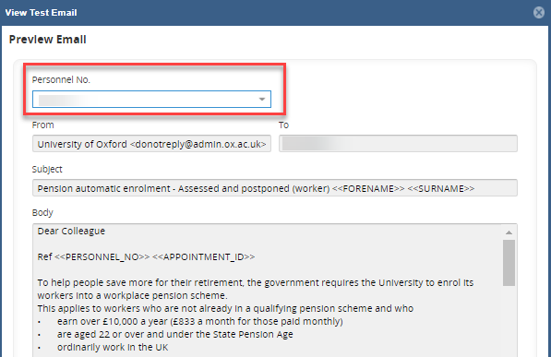
    - Click OK when done to close the window.

Edit Message Attachment
    - In the Event Maintenance window, click on the ellipses against the 'Event Type' you want to change and click Edit. In the pop-up window, select the notification you want to edit and click Edit:

    - The Event type window will open. The individual events will be displayed in the Event Notifications section. Click on the ellipses against the event you wish to amend and choose Edit.
    - A new window will open, displaying the configuration for the Auto Enrolment notification you have selected. Select the Message tab and view the 'Attachment' field:

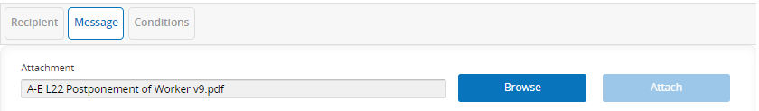
    - To update the attachment, click Browse. Navigate to the relevant folder and select the new attachment and click Open:
    - Click Attach to attach the document to the notification:
    - Click Save, then click Cancel or on the x to exit.

Edit Conditions
    - Click on the ellipses against the 'Event Type' you want to amend and choose 'Edit'.

    - The Event Type window will open. The individual events will be displayed in the Event Notifications section. Click on the ellipses against the event you wish to amend and choose Edit.
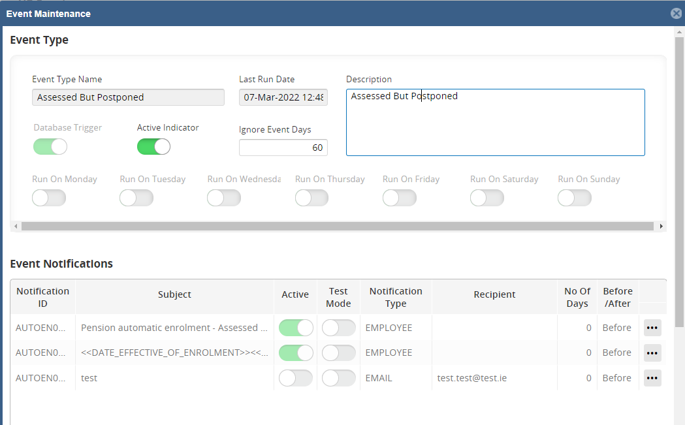

    - The Event Notification window will open:

    - Click on the Conditions tab and review the existing conditions:

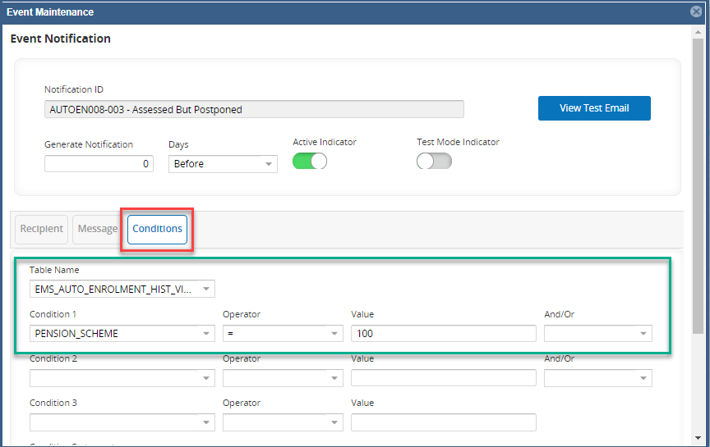
    - If the notification applies to particular pension schemes, these will be shown in the PENSION_SCHEME condition:
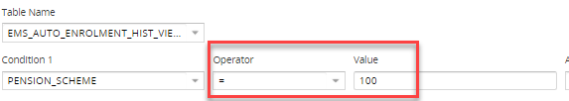
    - Click within the highlighted field to modify the pension schemes to which this notification applies.
    - Click Save, then click Cancel or on the x to exit.

Editing the Auto-Enrolment Parameters

Payroll Dashboard>UK Tax Rates>General>Maintain Statutory Pay Parameters

    - Scroll to the bottom of the screen and click on Auto Enrolment

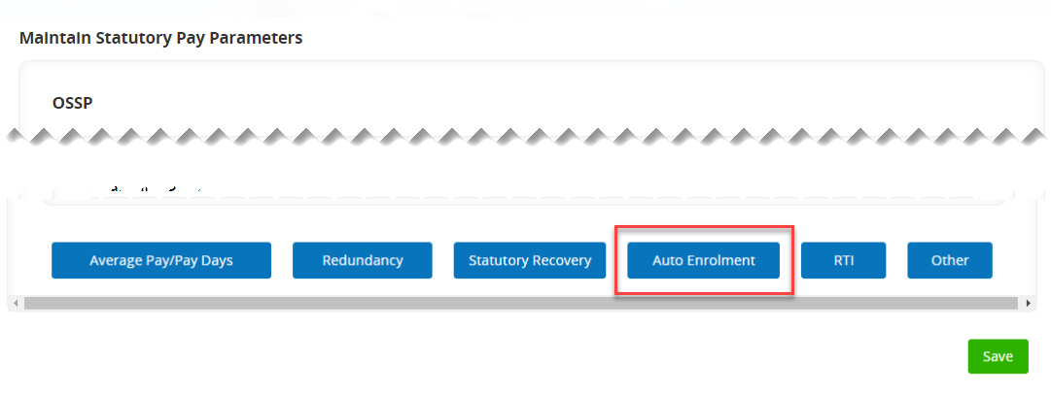

Edit Pension Rules
 | NB: If you add a new pension scheme, it may become a 'default' pension scheme, used by the Auto-Enrolment functionality to assign staff to pensions.  As a rule, pay grades 01S – 05S are auto-enrolled in OSPS by default, and pay grades 06S and above are auto-enrolled in USS by default. There are many grades which do not have a default scheme for auto-enrolment. Always ask Pensions to confirm whether the new scheme will be a default scheme for Auto-Enrolment.

    - In the Auto Enrolment Parameters window, select 'Pension Rules' under 'Options':
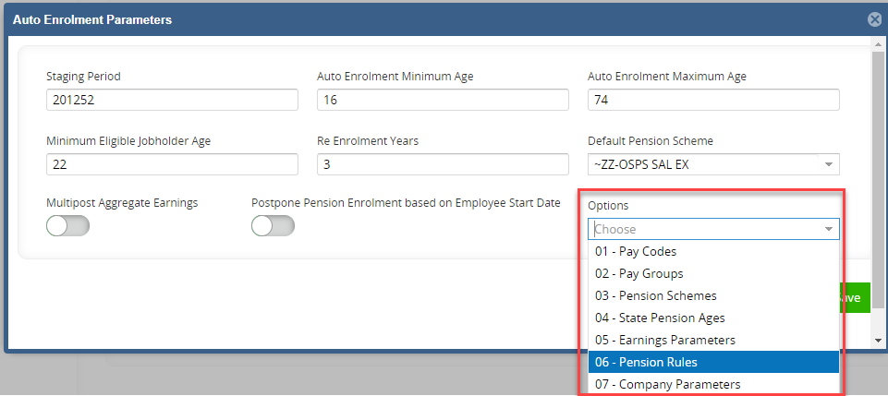
    - The Default Pension Rules tab will open. This window shows the pay grades (Positions), and the corresponding 'default' pension scheme for each.
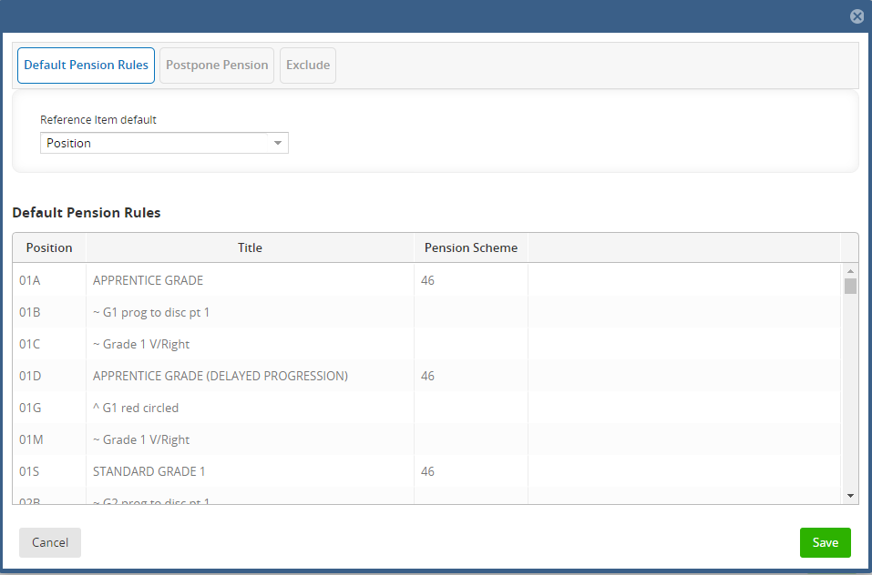
 | NB: If you are assigning a default scheme against a Position which hasn’t had one before, just type it into the blank Pension Scheme field:

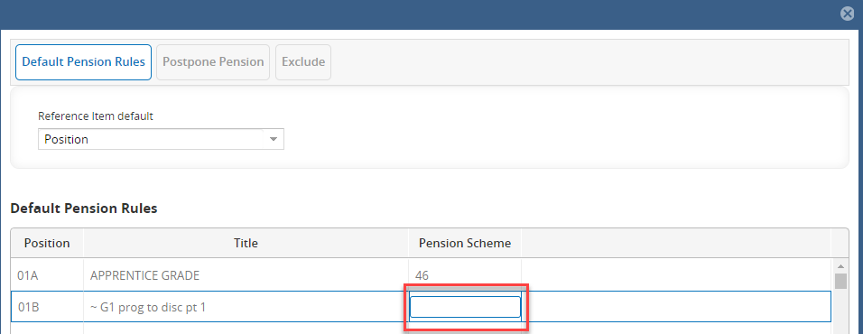
    - If you are replacing an existing default scheme with your new scheme code, overwrite the value of the existing scheme with the new scheme code:
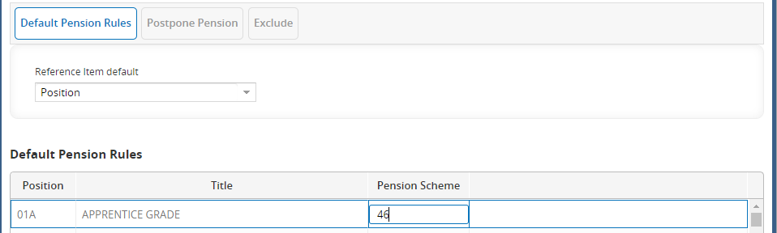
NB: You must make this amendment to every Position code which holds the existing scheme value; e.g. if you are replacing Pension Scheme 44 with Pension Scheme 45, you must replace all instances of '44' with '45'.

    - Click Save, then click on the x to exit.

Edit Earnings Parameters
 | NB: The Auto Enrolment Earnings Parameters change every year, and are delivered into the system as part of the Year-End Update from CoreHR. You can view the Earnings Parameters at any time by following the steps below.

    - In the Auto Enrolment Parameters window, select '05 - Earnings Parameters'
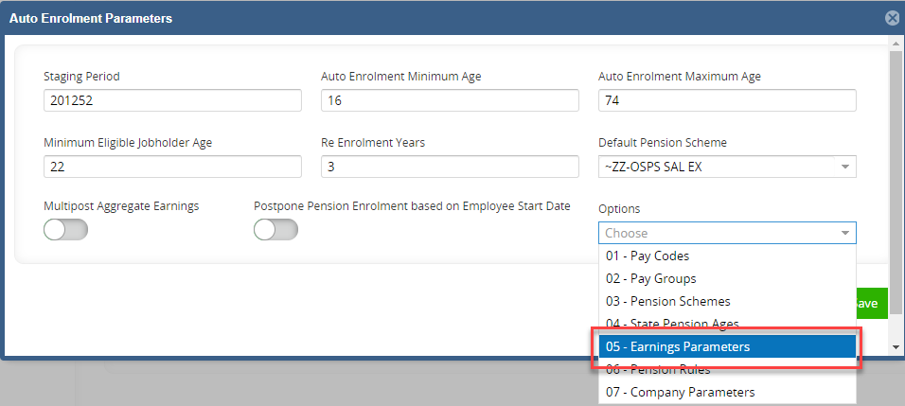
    - The Auto Enrolment Earnings Parameters window will open. This window shows Earnings Trigger and the Lower Qualifying Earnings Band for each financial year. The most recent year is always displayed at the top:

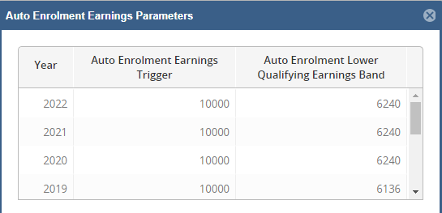

Note: Never edit these values unless you are explicitly instructed to do so by the Pensions team!

Edit State Pension Ages
 | NB: The State Pension Age is the age at which an individual can begin claiming their state pension, based on their gender and date of birth. It is set by the UK government, and is periodically revised. The Pensions team must inform HRIS Support when the State Pension Ages need updating.

    - In the Auto Enrolment Parameters window, select 'State Pension Ages':
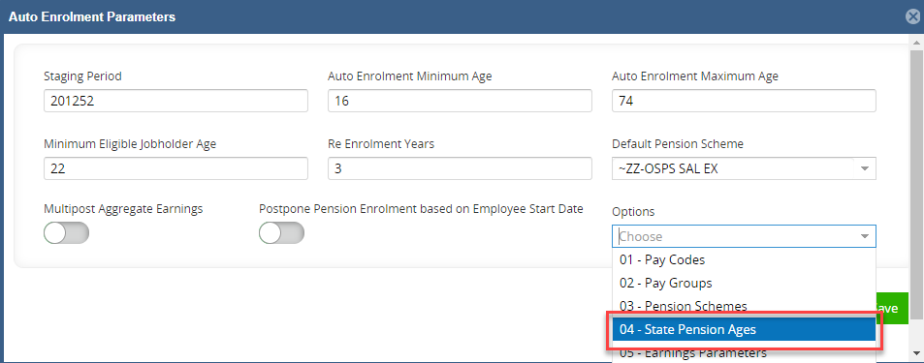
    - The State Pension Ages window will open. This window contains the appropriate pension age for an individual depending on their gender and date of birth:
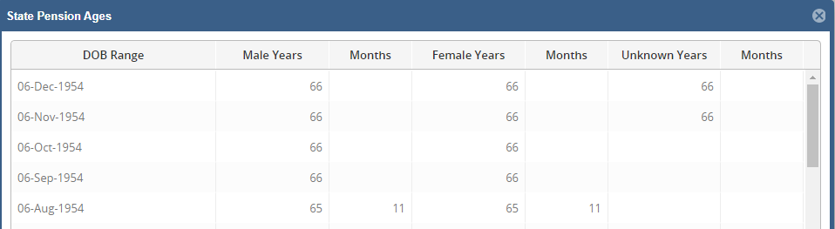
    - Click the new record icon (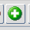) to create a new Date of Birth Range and the associated pension ages for male and female employees. Alternatively, you can overwrite the values in the grid.
Note: Never edit these values unless you are explicitly instructed to do so by the Pensions team!

    - Click OK to close the window, then click the yellow disk icon () to save your changes.

Editing the Re-enrolment Parameters

Payroll Dashboard>UK Tax Rates>General>Maintain Statutory Pay Parameters

    - Scroll to the bottom of the screen and click on Auto Enrolment



    - Under Options choose 'Pay Groups'

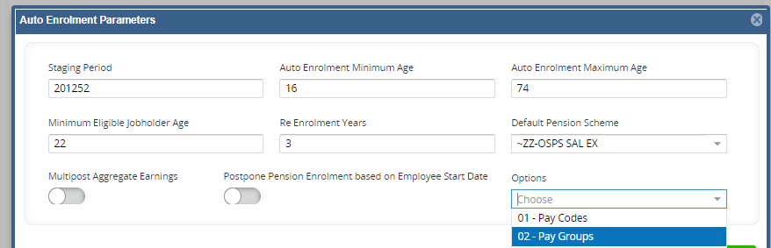

    - The Re-enrolment period should reflect the next planned exercise

